Triceratops Craft
Did you know?
Triceratops is Greek for three-horned face.

Materials:
- Empty toilet paper roll
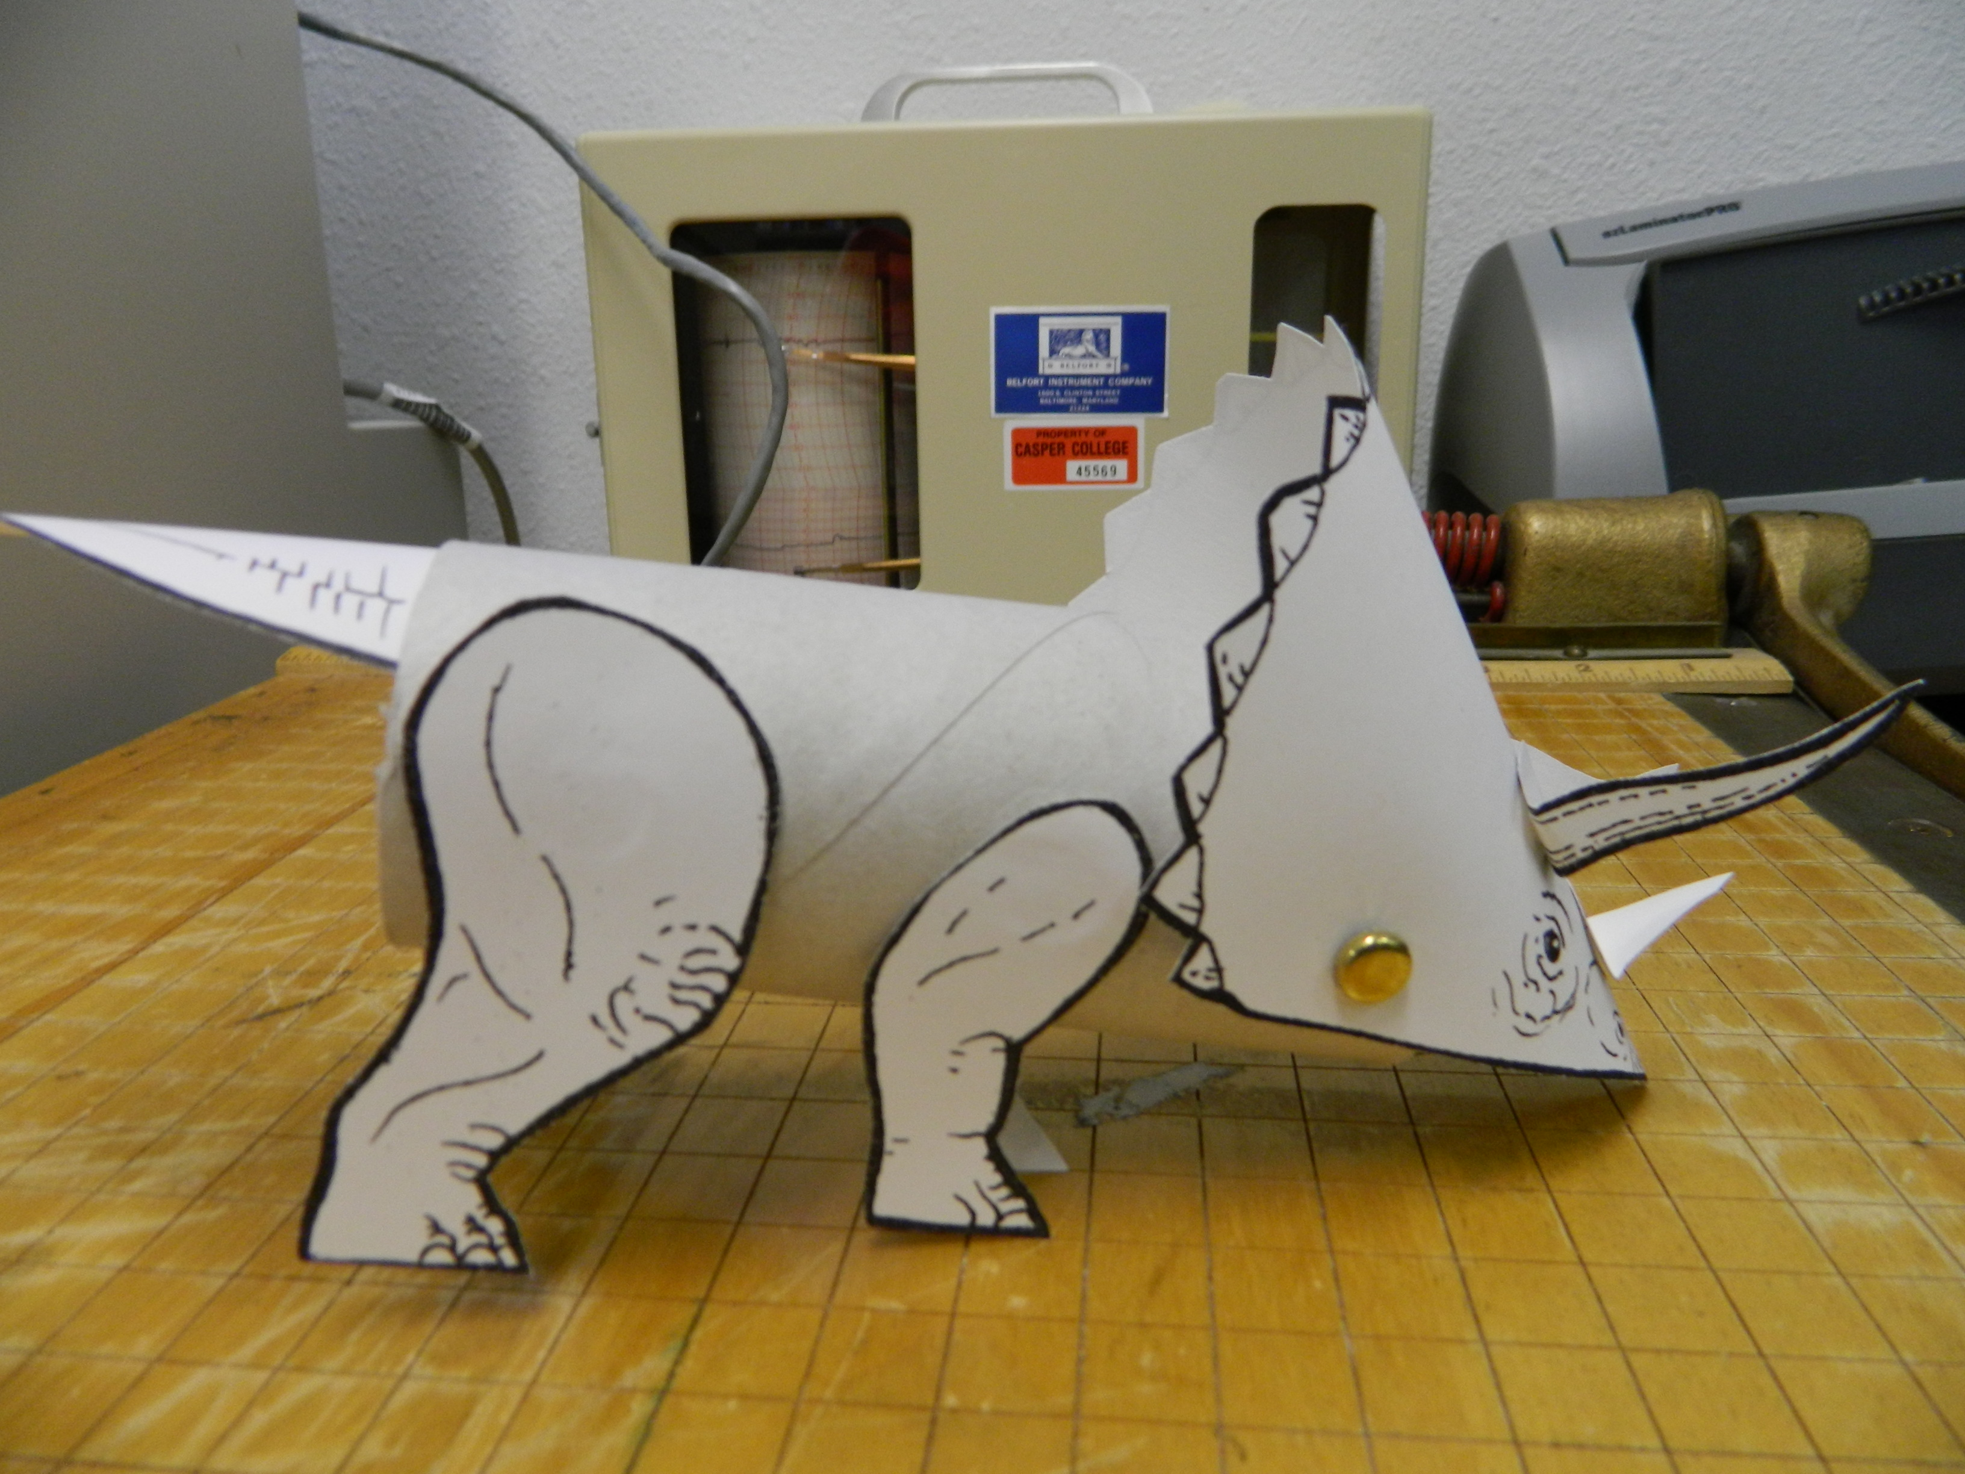
- Triceratops template
- Markers or crayons
- Glue
- 6 brads
- Tack for making holes

Directions:
- Print triceratops template on card stock.
- Color pieces if desired.
- Cut out pieces.
- Create a fold to the mandible piece along the dotted line and glue to the inside end of the toilet paper roll approximately ½ inch inside the roll with the printing piece facing down.
- Using the tack, poke a hole through each side of the toilet paper roll ½ inch back from the mandible
- Attach the head using the brads through the designated X’s and the holes you made in the toilet paper roll.
- Glue the longer horns above the eyes by folding along the curved dotted lines. Hold in place until dry.
- Glue the smaller nose horn between the nostrils using the same process as above.
- Poke holes with the tack in the tub where the legs will be.
- Place the shorter legs in front and the larger legs behind those.
- Glue the tail ½ inch into the top of the other end of the tube with the line drawing facing up.
