Lesson: The Road to Fossilization

4th grade Essential Curriculum: Earth Materials & Language Arts
Science Standards: 1DOK R 4.1.4 & 2 DOK ST, A 4.2.1, 4.2.2
Language Arts Standards: DOK W.4.2W.4.4W.4.5W.4.6W.4.10 L.4.2
Objective-Students will:
- learn about fossils by researching library and websites
- identify the different types of fossils
- learn how fossils form and when according to the stratigraphic ranges
- learn what happens to them based on the "Road to Fossilization" poster
- write an essay on the fossilization process in essay

Vocabulary: fossil, fossilization, compression, impressions, casts and molds, permineralization, trace fossils, stratigraphic ranges
Materials: Posters, computer, access to Internet and/or library
THE NPS Service Poster found at: http://www.nps.gov/fobu/forteachers/upload/Road%20to%20Fossilization10jul06.pdf
And poster: Stratigraphic ranges and origins of some major groups of animals and plants at http://pubs.usgs.gov/gip/fossils/succession.html
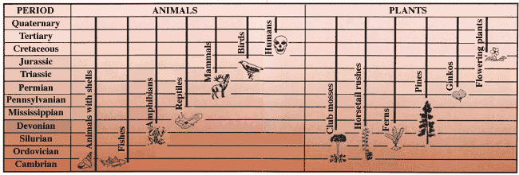
Website for Fossil Types at: http://www.dmns.org/main/minisites/fossil/whatfossil.html
Assessment: Students write an essay describing how fossilization occurs, how to identify the type of fossils researched and discussion questions regarding the ranges and origins of animals and plants. Students should cite references on bibliography page.

