Preschool Lesson Ideas-Dinosaur Unit
Create a dinosaur week!
The Big Ideas: Dinosaurs are animals that lived on Earth millions of years ago but are now extinct. Fossils and fossil imprints prove their existence. Paleontologists are scientists that dig up dinosaurs.
Decorate room with dinosaur pictures, get materials such as dinosaur toys, dinosaur flash cards, dinosaur coloring pages, dinosaur cookie cutters, dinosaur stuffed animals or puppets
Vocabulary: dinosaur, fossil, extinct, gigantic, paleontologist, dinosaur names
______________________________________________________________________________
Math
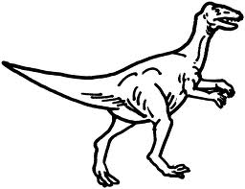Venn Diagram-Sorting Dinosaurs 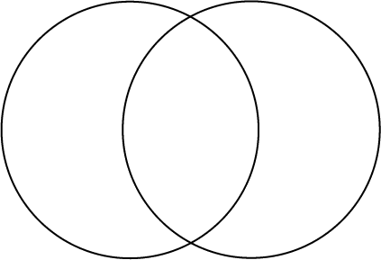
Procedure: Draw two overlapping circle on a piece of paper or use two hula hoops. Sort dinosaur cards or toys according to two characteristics. For example, dinosaur with long necks in one circle and dinosaurs with spikes in the other circle. Dinosaurs with both are place in the overlapping section.
Sorting Dinosaur Eggs
Procedure: Buy speckled jelly beans of various colors. Give each preschooler a bag of "dinosaur eggs." Have the kids sort by color or size. Preschoolers should count the sorted jelly beans and have teacher check to see if they are correct. Next record their findings on a dinosaur science journal and have students illustrate their page.

Dinosaur Tracks 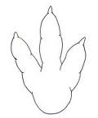
5
Tape 20 numbered paper dinosaur footprints onto the floor. Have your students toss a beanbag onto one of the number tracks. The student will say the number on the footprint track and then throw the bean bag to another student and repeat.
Literacy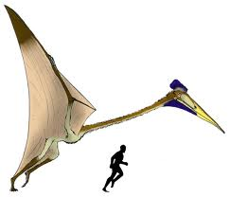
- Finish the story-If you met a dinosaur when walking through the park what would you do? Teacher writes words and children illustrate their story.
- Predict what comes next- The Quetzalcoatlus spreads its gigantic wings and took off to soar in the sky. What did she see below…
- If dinosaurs were living today, I would…
- I am a dinosaur with a long neck, every day I like to….
Baking Soda Clay
- 2 cups baking soda
- 1 1/4 cup water
- 1 cup cornstarch
- Food Color- follow box to make brown
Combine all ingredients in a pot. Stir while heating on low for about 15 minutes. Remove from heat and continue stirring. When it begins to look like mashed potatoes, it’s ready! Store in an air-tight container until use. Clay dries in about 12 hours (depending upon the thickness of the creation.) Once dry, the clay can be painted or colored with markers!

Art
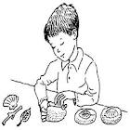Make fossil imprints with
Baking soda clay
After reading about dinosaurs and fossils; make fossils imprints!
Procedure:
- Make clay the night before.
- Give each student a paper plate and a small ball of clay
- Let them choose from the toy dinosaur which to imprint
- Label plates with dinosaur and child’s name
- Set plates up overnight to dry
- Next day they can color with markers or take home.

Melting Crayons into Dinosaurs
Procedure:
- Grate or smash up old crayons(sans label) onto pieces of copy paper
- Heat oven to 200 degrees
- Cover cookie sheet with another piece of wax paper and place dinosaur cookie cutters on wax paper
- Grab edges of copy paper with shavings and pour into cookie cutter shapes
- Place sheet in oven for approximately 45 minutes
- Let cool and remove cookie cutters.
(Variation: Put old crayon chunks into small paper cups, and place them in the microwave for about 4 – 6 minutes on ‘high.’ Pour the melted wax into cookie cutters on wax paper and place in the freezer for about 20 minutes. Once the wax has hardened, your new crayons will pop out of the cookie cutters)
Dinosaur Lotion Bars
Equal parts:
- beeswax, shea butter, and sweet almond oil
- 15 drops essential oil (optional)
- weigh out your three ingredients so they all measure the same (3 oz makes a large size dinosaur).

Dinosaur Bath Crayons
Materials:
- 32 oz. Clear Glycerin blocks – Can buy at craft store
- 3 bright colored gel paste food coloring (Ex: AmeriColor) Can buy at craft store
- Glass microwavable measuring cup
- Plastic spoon
- Dinosaur or other chocolate molds (Ex: Silikomart Silicone Chocolate Mold or
Tip: One cube of glycerin makes 8 small dinosaurs if using chocolate mold.
Melt about 2 cubes of the soap bar glycerin in the glass bowl in microwave at 30 second intervals, until completely melted. Make in color batches.
Add 1/4 teaspoon of the gel paste food color. Work quickly from the microwave, to the food coloring mixing, to pouring into the molds as the mixture quickly hardens. If it begins to harden while you are still stirring in color, place back in microwave for another 20-30 seconds. Mix coloring in completely. Pour into molds. Leave in molds for at least 4 hours at room temperature.
Science 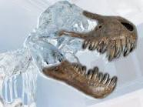

Dinosaurs Frozen in Time

Materials:
- various plastic recycled containers
- sand
- shells
- plastic toy dinosaurs
- cleaned chicken bones or other artifacts
- old paintbrushes
- toothpicks
- tweezers

Vocabulary: dinosaur, extinction, paleontology, erosion, liquid, frozen, melt
In plastic containers, have students place sand, shells, dinosaurs, etc… and fill with water leaving room at the top for ice to expand. Freeze overnight. Once containers are frozen, place them in a big tub and have students experiment in removing dinosaurs and other artifacts, using hands, warm water, toothpicks, brushes and other ways.
Students will notice a change in textures as the ice melts and how to be careful in removal by not breaking shells, just like a paleontologist. This experiment gives students experience working as a paleontologist in digging out dinosaur bones, water erosion (warm water).
Motor Development: Using tools develops fine motor skills necessary for writing.

Music
Check out the site: http://www.kidsparkz.com/preschoolsingsdinosaurs.html
Examples: Sung to: "The Wheels on the Bus"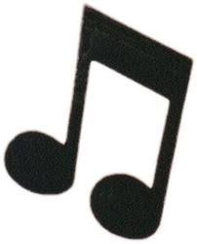
The Pteranodon's wings went FLAP, FLAP, FLAP,
FLAP, FLAP, FLAP, FLAP. FLAP, FLAP
The Pteranodon's wings went FLAP, FLAP, FLAP
All around the swamp.
The Tyrannosaurus Rex went GRRR, GRRR, GRRR,
GRRR, GRRR, GRRR, GRRR, GRRR, GRRR,
The Tyrannosaurus Rex went GRR, GRR, GRR,
All around the swamp.
The Triceratops horns went POKE, POKE, POKE
POKE, POKE, POKE, POKE, POKE, POKE,
The Triceratops horns went POKE, POKE ,POKE,
All around the swamp.
The Brontosaurus went MUNCH, MUNCH, MUNCH,
MUNCH, MUNCH, MUNCH, MUNCH, MUNCH, MUNCH
The Brontosaurus went MUNCH, MUNCH, MUNCH,
All around the swamp.

The Stegosaurus tail went SPIKE, SPIKE, SPIKE,
SPIKE, SPIKE, SPIKE, SPIKE,
SPIKE, SPIKE,
The Stegosaurus tail went SPIKE, SPIKE, SPIKE,
All around the swamp

