Polar Bears
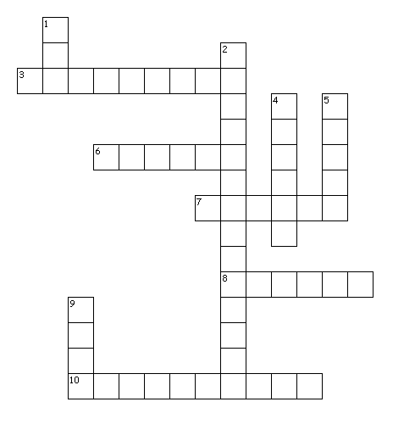
Across
3. Largest land predator
6. Only predator of a polar bear
7. What Inuits call polar bears
8. Polar bear paw width in inches
10. Polar bear favorite food
Down
1. Number of cubs a polar bear mom has
2. Species name for polar bear
4. Shaft of polar bear hair
5. The color of polar bear skin
9. Male polar bear

