Going on a Site Dig: All the things a paleontologist needs
  - Rock hammer
  - Brushes
  - Water bottles to wash off specimens-makes it easier to see
  - Paper Towels-for wrapping to protect from plaster
  - Burlap-for covering the plaster
  - Aluminum Foil- to wrap casts
  - Shovels- to dig up earth
  - Baggies to hold specimens
  - Plaster
  - Markers-for labeling specimen
  - Glue to hold specimens together
  - Hats
  - Sunscreen
Back at the museum- Cast cutter, air scribe, dental picks, consolidant,-strengthening liquid paint to preserve bones and a lot of patience!

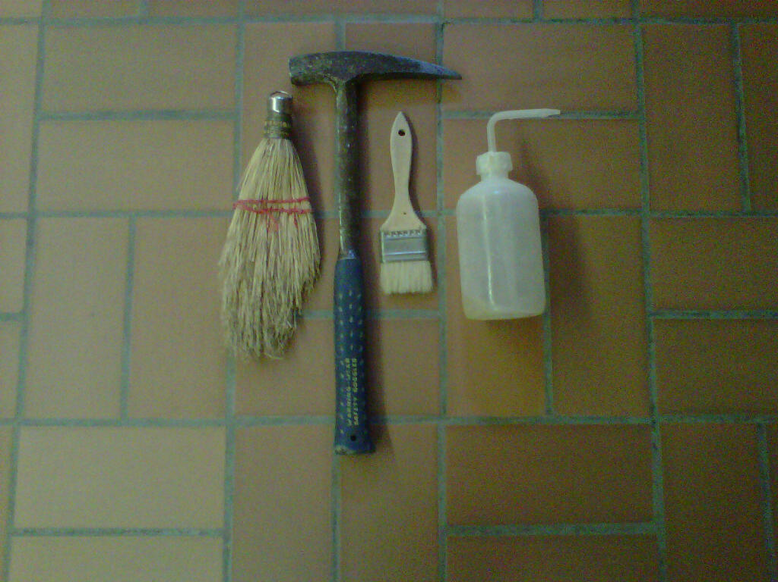
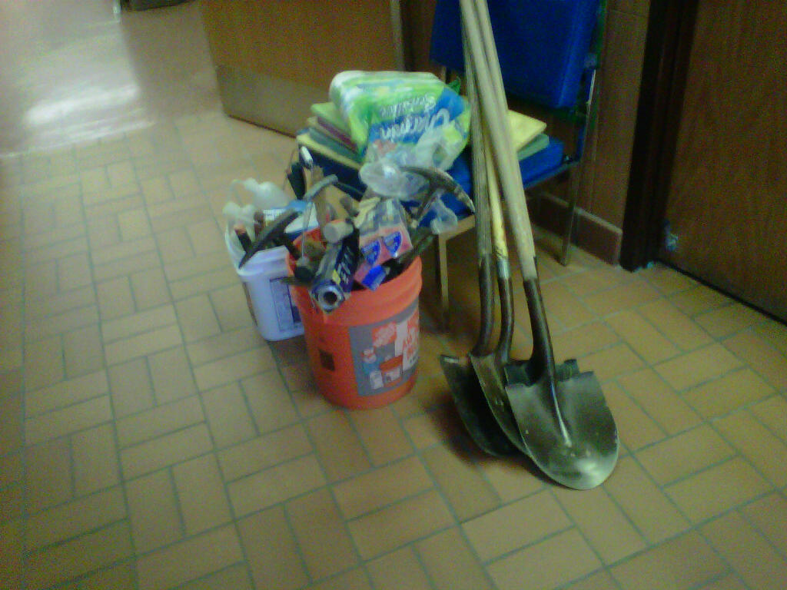

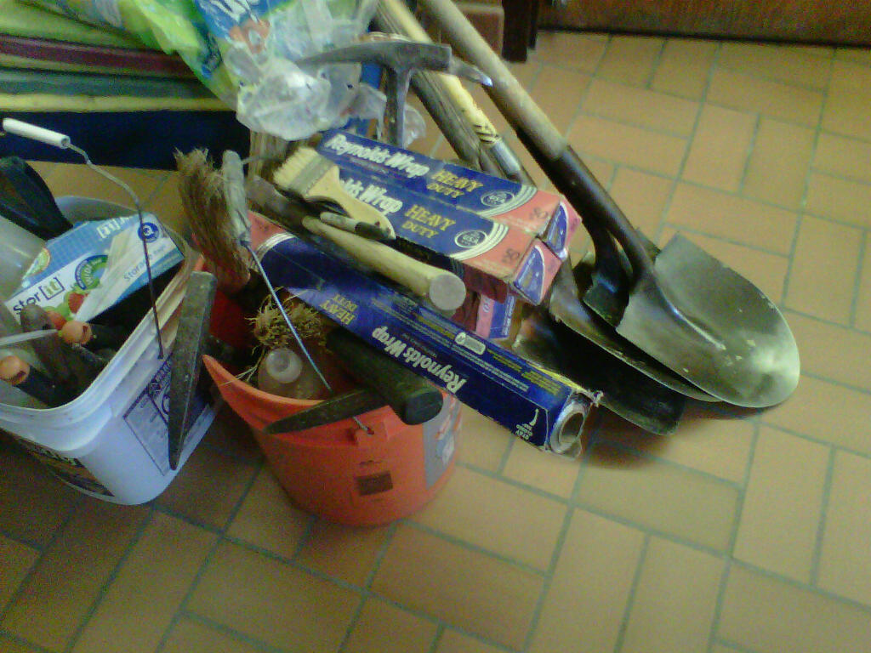
Now go explore the interactive game on the Smithsonian site: http://paleobiology.si.edu/dinosaurs/interactives/dig/main.html

