Lesson Plan: Deer & Wolf Postural Communication
Grade Level: 5th-8th grade
Standards: WDE Science:
SC8.1.4 | Diversity of Organisms: Students investigate the interconnectedness of organisms, identifying similarity and diversity of organisms through a classification system of hierarchical relationships and structural homologies.
Objective: Students will learn:
- how animals respond to cues
- how animals use non-verbal communication for mutual protection and interaction with other animals
- how communication strengthens deer survival
- how to simulate animal communication through a predator/prey simulation
- facts about wolves and white tail deer
Materials:
- 3 white napkins
- Access to play area
- Cones to mark boundaries of play area
- Internet with speakers
- Optional: Smart Board
Anticipatory Set:
Play the sound of a white tail and let students guess what animal it is. Sound found at: http://animals.nationalgeographic.com/animals/mammals/white-tailed-deer/ Share the background facts about the deer and ask them if they have ever seen one? If so, ask how they knew it was a white tail deer? Share the YouTube clip of white tail deer in action: http://www.youtube.com/watch?v=-NM1Wnykk3c
Play the sounds of wolves and let students guess what the wolves are trying to communicate. There is also a clip of wolves howling at http://www.wolfcountry.net/WolfSounds.html

Preparations:
- Students will portray a herd of deer and a pack of wolves.
- The students portraying the deer will exhibit the different alarm displays as described below. Explain these behaviors to students before the game.
- Students portraying the wolves need to follow hierarchy and follow the alpha wolf (teacher assigned).
- The playing field for this game is made up of two parallel boundary lines and a middle line, with about 75 feet in between. The entire playing field should be about 150 feet. One end is the boundary of the wolves (Predators) the other end is the boundary or safe haven for the white-tailed deer (Prey).
Deer Alarm Behaviors:
- Foot Stomp - The deer will lift its forefoot slowly, pause, and then stamp downward with great force. This is used when a deer is alarmed but cannot identify the object of its suspicion.
- Head Bob - The head is bobbed up and down. The deer begins to lower its head toward the ground as if to feed but then quickly jerks its head back up. This is a typical response to an unidentified object or motion.
- Tail Flag - The tail is held up and wagged loosely from side to side exposing the white underside and rump patch. The tail flag is used when running from danger, real or imagined. This helps to keep the group together when fleeing (as in the YouTube video clip)
- All Clear - When a deer wags its tail once, in a casual side-to side tail flick, it often is an "all clear" signal.
Students Deer Displays
- Foot Stomp - Slowly lift one foot at a time and stomp your foot on the ground. Made by the general deer population.
- Head Bob - Bob your head up and down. Made by the general deer population.
- Tail Flag - A whole arm wave with the white napkins in hand. The lead deer use this signal or display to alert the other deer to run.
- All Clear - A quick hand wave with the white napkin. Used by the lead deer.
Wolf Displays
- The alpha wolves carry their tails high and stand tall.
- Less dominant wolves exhibit submissive behavior by holding their tails down and often lower their bodies while pawing at the higher ranking wolves.

Students Wolf Displays
- Alpha wolf-stands tall
- Other wolves- stoops lower to the alpha and keep an eye on the alpha wolf

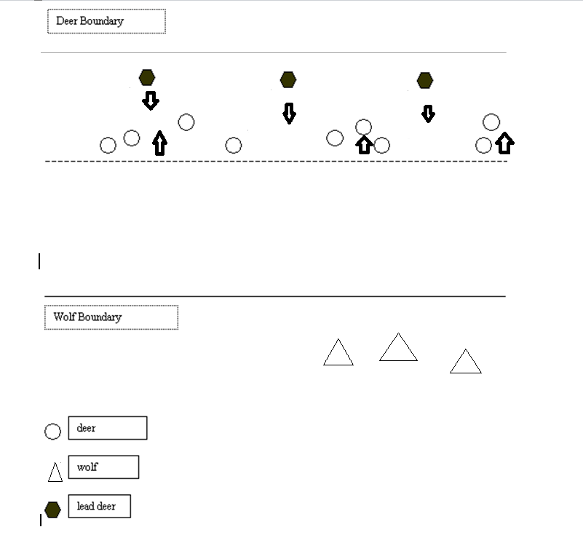

Procedure:
1. Select students to represent 3 wolves, one acting as the lead wolf, to about 22 deer. You can add another wolf if needed. Also, you need to pick 3 lead deer who receive a white napkin, representing their tail. The lead wolf does not receive anything.
2. Begin the wolves at one end of the playing field while the deer start on the opposite side of the center line from the wolves. Ask the lead deer to spread out among the other deer while they eat and say "munch, munch, munch." The larger deer population needs to watch the lead deer for signs of danger, and have their backs to the wolves. Only the lead deer face the wolves and they must alert the other deer if the wolves get too close.
3. Instruct the wolves to sneak up on the deer from their end of the playing field. The lead wolf will coordinate with the rest of the pack to see what strategy they want to use (e.g. attack slowly on one side, walk in a few circles to try and fool the deer, etc.) The, lead deer should raise their tails (napkins) as the wolves get close. This should alert the deer population, who should stop eating and "foot stomp" and "head bob" in reaction to the warning. The deer population should only look at the lead deer closest to them.
4. When the wolves get really close, the lead deer should do a "tail flag" which is a signal for all of the deer to run to the boundary or safety. It is up to the lead deer as to when to change the from a "tail flag" to an "all clear." The wolves will try and catch a deer (one deer for each round). If they do, the deer that are caught become wolves. The deer population is safe once they reach the boundary line. The lead deer can also be tagged. If one of the lead deer are caught, she or he passes the flag to another deer that has already made it to safety. The wolves can decide to be tricky, and go back and forth from their home base to very close to the deer population before actually trying to catch a deer. If the wolf were to go back to home base, the lead deer should give an "all clear" signal, and then the other deer can go back to eating.
The game is over when most of the deer become wolves and/or the kids are ready to switch. The lead deer should become wolves in the next game, and the wolves should become part of the regular deer population. Students should take turns and be a different animal in the next game.
Note-for the lead deer: It may be tempting for the lead deer to have the entire deer population run each time predators come near, but keep in mind that deer need to conserve energy. If the entire deer population run rather than using their other signals to keep each other on alert, then the deer could weaken and use up energy that they would otherwise need to survive.
Source: Kuehn, J. (2002). Wisconsin Department of Natural Resources Retrieved Online: http://dnr.wi.gov/org/caer/ce/eek/teacher/deertalkactivity.htm
Follow Up Questions
- Discuss what was realistic and what was not in this game. (All deer signal each other, not just the lead deer; this was a simulation and not an example from real life, etc.)
- Was it difficult to be the lead deer? If yes, how so? If no, why not?
- Was it difficult to be a wolf? If yes, how so? If no, why not?
- How well do you think the non-verbal communication worked for your group?

Background: Facts about the White tail deer:
- Are the smallest members of the North American deer family
- Are herbivores and eat many types of plants, twigs and lichen
- Found from southern Canada to South America
- Have reddish-brown coats in summer which fade to a duller grayish-brown in winter
- Males are called bucks and only the bucks grow antlers
- Female are called does and give birth to one to three young at a time in the Spring(gestation: 7 months)
- Young are called fawns and wear a reddish-brown coat with white spots that helps them blend in with their surroundings.
- Are preyed upon by bobcats, mountain lions, humans and coyotes
- White-tailed” refers to the white underside of the deer’s tail, which it displays and wags when it senses danger
Source: http://animals.nationalgeographic.com/animals/mammals/white-tailed-deer/

Background: Facts about the Wolves:
- On average, each wolf pack kills an animal every 2.2 to 2.7 days.
- A wolfs need roughly three to ten pounds of meat each day.
- After prey is detected, wolves may split up to search through brush, travel on ridge tops searching for the prey below, or test herds looking for signs of weakness.
- Wolves kill the weak, young, slow, sick or injured first.
- When hunting in winter the wolf will conserve energy, by following the same trail as the prey animal, staying upwind, and staying out of sight of the prey as long as possible.
- When it is time to strike the wolves will start wagging their tails with excitement.
- Contrary to popular belief, most prey chased by wolves actually gets away.
- Wolves use body language to convey the rules of the pack and a wolf pack is very organized.
- Rule number one says that the pack is made up of leaders and followers. The pack leaders are the male parent and the female parent - usually the father and mother of the other pack members. They are likely to be the oldest, largest, strongest and most intelligent wolves in the pack. They are known as the alpha wolves and are usually the only members of the pack to produce pups.
- To communicate dominance, the alphas carry their tails high and stand tall. Less dominant wolves exhibit submissive behavior by holding their tails down and often lower their bodies while pawing at the higher ranking wolves.
- Weakened animals may show their condition to predators through body stance, uncoordinated movements, the smell of wounds or infection, or some other tangible signal. The reading and evaluation of these signals comprises what Barry Lopez has poetically termed "the conversation of death." (WolfCountry.net, 2013).
Enrichment: Visit the Werner Wildlife Museum in Casper, Wyoming to see their deer and wolf specimen.
Sources:
http://www.wolf.org/wolves/learn/basic/biology/communication.asp
http://www.wolfcountry.net/WolfSounds.html

