Lesson Plan: Comparing and Contrasting Elephants and Mammoths

Standards: 5th Grade Understanding Life Systems and Life Science Classifications A 8.1.3 & .5
Objectives: Students will:
- Identify mammoth skeleton bones by comparing and contrasting elephant and mammoth skeleton bones
- Explore the ancestry and evolution of elephants
- Hypothesize why elephants still exist and mammoths are extinct
- Journal their findings and hypotheses

Materials: Computer with online access, Russell Hawley’s drawing of mammoth skeleton worksheet (attached) and Russell Hawley’s Late Pleistocene elephant illustrations.
Procedure:
- Students will research elephant skeletons online
- Compare and contrast mammoth skeleton bones to elephant skeleton
- Complete attached worksheet identifying Dee the mammoth’s skeleton and review attached Russell Hawley illustrations and other ancestral chart
- Have students research and answer the following questions: Did elephants evolve from mammoths? (No, in the same family but elephants and mammoths were alive at the same time) Why do you think elephants are still living and mammoths are not? ( Many theories- ex: drastic change to their habitat)
- Write a short summary regarding the similarities and difference between mammoths and elephant in a science journal
- Write an educated hypothesis to the question: Why are mammoths extinct? and include in your science journal.
- Post Lesson: Visit the Tate Geological Museum to see Dee the Mammoth exhibit

Example Source: http://www.himandus.net/elefunteria/library/science+nature/evolution.html
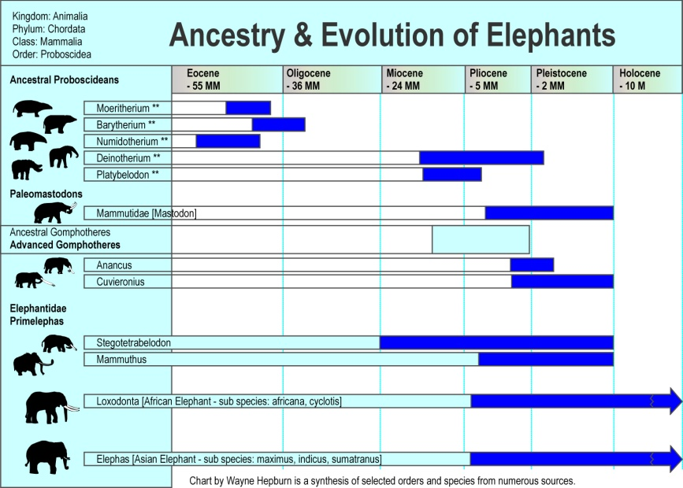

Attach Russell’s elephant family illustrations here.

