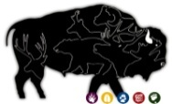
ANIMAL TRACKS – WHAT DO THEY REVEAL?
Field Journal: Animal Track Data
Name __________________________________________________________________
Location of trap _______________________________________ Date _________________
Type of bait used ___________________________________________________________

Describe the location and surroundings of your track trap. (For example: is the ground wet or dry, are the tracks on a path, near the dumpster, near a building, etc…?)

What do you think the animal was doing? Describe the actions of the movement.

Measure the length of the track and record | Measure the stride length and record  (distance between the heel of one foot and the heel of the opposite foot of the same animal)

Draw a picture below

