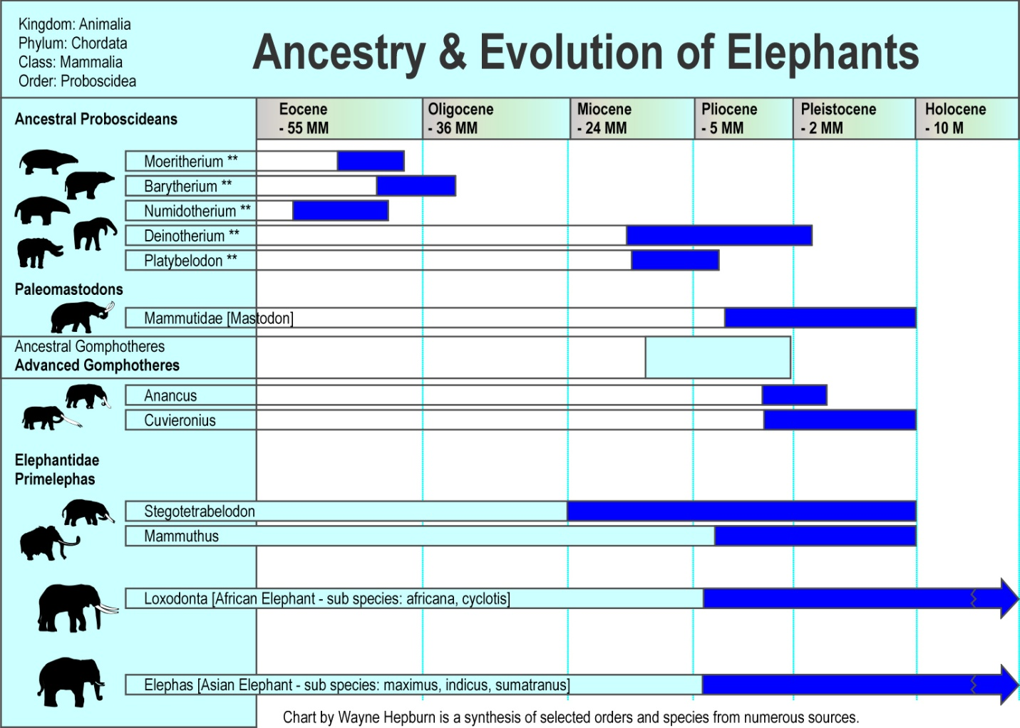
http://www.himandus.net/elefunteria/library/science+nature/evolution.html

