Lesson Plan: Women in Paleontology

Standards: 6th Science Writing in Science
Objective: Students will learn about paleontology and the important contributions that women have made to the science.
Vocabulary: paleontology, Women’s History Month, contributions to science
(In addition, have students define any scientific terms they come across in their research, for which they do not know the meaning)
If possible, teach this class during March as it is Women’s History Month.
Procedure:
- Ask students a few trivia questions, listed below.
- Share the story of Dr. Mary Anning
- Talk about women’s contributions in science.
- Talk about the challenges that women had in the sciences, especially how many discoveries women made were often credited to men.
- Assign each student a name from the list below.
- Have them research their paleontologist and write a short essay about her, answering the following questions:
- How did she get into the field?
- What was happening in history at that time?
- What challenges did she face as a scientist?
- What was she credited with and how did she make a name for herself?

- Using the scientist’s time in history, have the student write a comparison of a female family member. For instance, if the student is assigned, Zofia Kielan-Jaworowska, the student would work inside the 1925-current timeline. They would write a short essay about their great grandma or grandma’s life story. Enrichment: Compare and contrast the women’s lives.
- Finally, have the students think about what they would like to do for a career and write the steps to reach their goal.
- Share their essays with the class.

Trivia Questions:
- Who was the ecologist writer whose path breaking book, "Silent Spring" in 1962 initiated the environmental movement? Rachel Carson
- Who was the astronomer who discovered a comet, named for her, on October 1, 1847, and who was the first woman elected to the American Association for the Advancement of Science (1850), and the first professor of astronomy at Vassar College? Maria Mitchell
- Who was the first person to discover an Ichthyosaurus and a Plesiosaurus? Dr. Mary Anning
- For more women trivia questions go to: http://www.nwhp.org/whm/test.php

List of Women Paleontologists
(Hint: If students are using the Internet to research, have them place + paleontology after the scientist’s name to increasing filtering of search.
Angela Milner
Anna Kay Behrensmeyer
Annie Alexander
Anusuya Chinsamy-Turan
Blaire Van Valkenburgh
Catherine Bosivert
Cathy Forster
Elisabeth Vrba
Elizabeth Harper
Elizabeth Nicholls
Halszka Osmolska
Jenny Clack
Jessica Theodor
Judy Massare
Julia Clarke
Julia Heathcote Anderson
Karen Chin
Kelli Trujullo
Kristi Curry-Rogers
Lindsay Zanno
Louise Leakey
Mary Dawson
Mary Leakey
Mary Schweitzer
Meave Leakey
Melanie Crisfield
Melissa Connely
Nancy Stevens
Natalia Rybczynski
Olga Potapova
Patti Kane-Vanni
Rebecca Hunt-Foster
Ruth Mason
Susan Cachel
Tilly Edinger
Zofia Kielan-Jaworowska

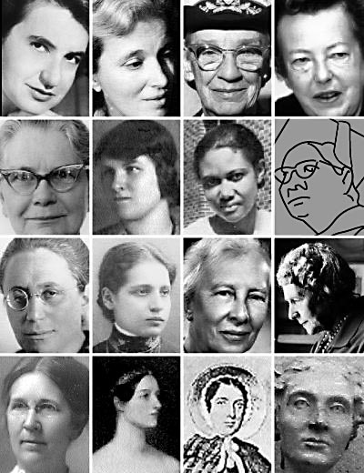

http://www.sdsc.edu/ScienceWomen/anning.html
http://txchnologist.com/post/32812033713/are-womens-scientific-achievements-being-overlooked

