Lesson Plans: Fabulous Fibonacci through Time

Standards: 6th Grade Math: Standard #2: D-R/A/P 6.2.1. & 3
6th Grade Science: Data can be used as evidence to support findings or to create explanations ST 8.2.1
Objective: Students will examine how the Fibonacci principle of equiangular spirals existed throughout time by identifying animals and plants represented in the geologic time. Students will learn to apply the Fibonacci Golden Rectangular math principle.
Materials: Computer with Internet access, Fibonacci Equiangular Spiral through Time chart, computer with Internet access, Graph paper, pencils, Scavenger Hunt Worksheet
Vocabulary: Fibonacci principles, Geological periods, terms in graph equiangular chart, patterns

Examples of the Fibonacci Equiangular Spiral through Time
Period | Animal | Plant
Quaternary | Mammoth Tusk | Sunflowers( H. petiolaris)
Tertiary | Prehistoric Big Horn Sheep | Ferns, Fossilized Pinecones
Cretaceous | Ammonites
Jurassic |  | Sequoia Pinecone
Triassic | Ceratites | Cycadeoidea (Pineapple)
Permian | Whorl Tooth Shark (Helicoprion) | Araucaria Cones
Pennsylvanian | Gastropod | Leaf Whorl Impression
Mississippian | Horn Coral, Spiral Bryozoa
Devonian | Goniatites
Silurian | Nautilus
Ordovician | Split Snail, Receptaculites
Cambrian | Foraminifers

Procedure:
- First give each student one organism’s name in the Fibonacci’s equiangular chart to research online. For example: Ceratites. 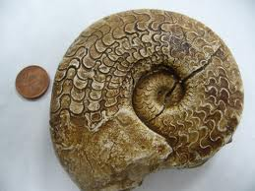
- Have students find a picture of it on the web and print. (Google images is a good place to search)
- Next have student draw a spiral on the printed picture creating the Fibonacci equiangular spiral.
- Then, have students create their own equiangular spiral on graph paper by following the directions below:
  - Start with a 1 unit square □
  - Attach another 1 unit square to it.
  - Attach a 3 unit square where it fits
  - Continuing in the same direction by attaching squares 5, 8, 13, 21, 34, 55, 89, 144 or however long the students wants to draw it.
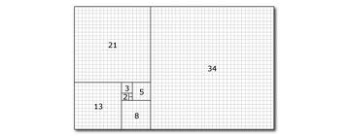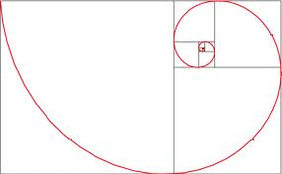
Discussion: Students will compare and contrast their pictures that demonstrate Fibonacci’s equiangular spiral throughout geologic time. Next, students will discuss, where in nature they see Fibonacci’s equiangular spiral today, even on their own body.
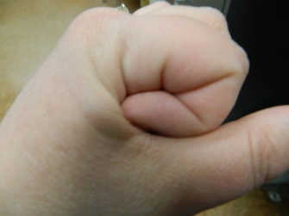
Post Activity: Teacher will take students to the Tate Geological Museum and have a scavenger hunt to find examples of Fibonacci’s equiangular spirals throughout Geologic time.

Tate Geological Museum

Scavenger Hunt

Fibonacci Equiangular Spiral through Time
Period | Animal | Plant
Quaternary
Tertiary
Cretaceous
Jurassic
Triassic
Permian
Pennsylvanian
Mississippian
Devonian
Silurian
Ordovician
Cambrian

Other: ___________________________________________________________________________

