Comparing our state fossil Knightia anatomy to our current state fish Cutthroat Trout.
Standards: 8th Grade Science R 8. 1. 4 &5, A 8.3.2
Objectives:
- learn about the origins and extinction of Knightia, Wyoming’s state fossil
- learn about the origins of Cutthroat Trout, Wyoming’s state fish
- compare and contrast fish families of the Clupeidae and Salmonidae
- discuss differences between families of fish (this lesson covers Clupeidae and Salmonidae)
Materials: pictures of Knightia and cutthroat trout, background information of both, fish labeling worksheets (attached)
- Vocabulary: Clupeidae, Salmonidae, Knightia, Caudal Fin, Dorsal Fin, Anal Fin, Adipose Fin, Pectoral Fin, Pelvic Fin, Gill slit, Pharyngeal Cavity, Lateral Line, Naris, Maxilla, Mandible, Kype
Procedure:
- Have students study background information of both fish species. Then have students compare and contrast the fish anatomy. Ask: how are they the same how are they different?
- Research a fish family, such as Clupeidae or Salmonidae and write down three identifying factors such a lateral line or adipose fin
- Using the diagram below, label the fish parts on each fish
- Then write a brief description of each fish and how anatomy helps fish survival
- For enrichment an activity: Have your students take the online fish identification quiz at: http://gf.state.wy.us/fishexam/frmExamQuestion1.aspx
Field trip idea: Visit the Tate Geological Museum to see Knightia fossils and visit the Werner Wildlife Museum to see the cutthroat trout specimen and other fish specimens and compare and contrast fish anatomy.

Background Information:
Knightia History: Knightia was a small species of freshwater herring that lived and died in the Eocene Epoch, approximately 50 million years ago. Knightia is found abundantly in the Green River formation of Wyoming in the limestone strata. The fossil evidence suggests that Knightia traveled in schools. Paleontologists speculate that rapid changes in temperature or changes in lake chemistry may have been the cause to its extinction, as Knightia, like the modern herring, seemed to be sensitive to temperature changes. Thus, Knightia were preserved by being quickly buried in sediment in a low oxygen environment. This lack of oxygen slowed the decay and increased precipitation of the calcium carbonate that eventually became limestone and allowed for the abundance of their fossil record.
Knightia the Fish: Knightia belong to the Clupeidae family. This primitive fish has a deeply forked tail, which would have made it a speedy swimmer. The pelvic fins were too small to be of much use; however the enlarged anal fin formed a long fringe on the fish’s underside perhaps providing stability. The pectoral fins were placed high on the sides allowing for great maneuverability in swimming. Knightia is the Wyoming state fossil of Wyoming and the most abundant vertebrate fossil in the world.
Cutthroat Trout: is a freshwater fish belonging to the Salmonidae family and our native to the western United States. It is also the Wyoming state fish and the only trout native to Wyoming.
Animation of trout anatomyhttp://www.streamexplorers.org/fish-facts/external-anatomy
http://www.allfishingbuy.com/Fish-Species/Salmon-Trout-Family-Species.htm

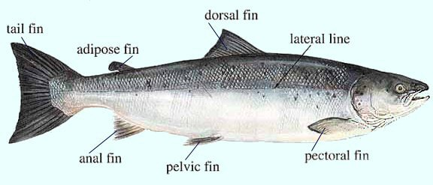
Picture of a trout

Picture of Knightia fossil found at the Tate Geological Museum
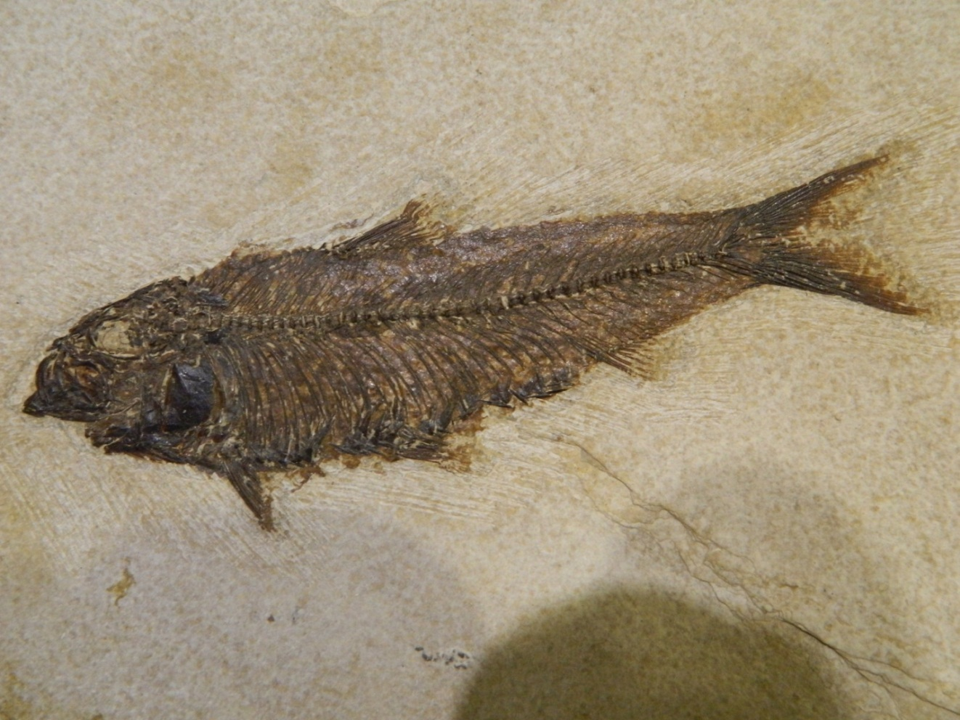

Fish Anatomy
Name_____________________
Using the diagram below, label the parts on each fish and identify fish family. Not all letters will on each fish.
- What family does this fish belong?____________________________________
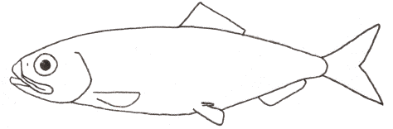
- What family does this fish belong?______________________________________
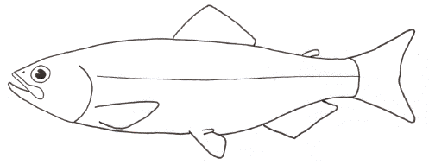
- Caudal Fin-pushes and steers fish
- Dorsal & Anal Fins-helps steady the fish
- Adipose Fin- stores fat
- Pectoral fins- helps steer and slow down fish
- Pelvic Fin- helps fish swim up and down
- Gill slit- allows CO² laden water to exit the pharyngeal cavity
- Lateral Line- senses movement around the trout
- Naris- smells odors underwater
- Maxilla- upper jaw
- Mandible- lower jaw
Extra Credit: Label where the kype would be if fish # 2 had one and what is it?

